**1. WEB PAGE CREATION**

|  |  |
| --- | --- |
| NAME | VAISHALI |
| SAP ID | 500093160 |
| COURSE | BBA (ANALYTICS AND BIG DATA) |
| SUBJECT | WEB ANALYTICS |

**INPUT:**

<html>

<head>

<title>Welcome To Web Analytics</title>

<body background="C:/Users/Admin/Downloads/photo-1531012278403-e5db3b774373.jfif">

<marquee>WEBPAGE</marquee>

<b>UPES DEHRADUN</b> <br>

<i>BBA IV SEM</i> <br>

<u>WEB ANAYTICS</u> <br>

<p>WEBSITE FOR WEB ANALYTICS</P>

<ol>

<li>one</li>

<li>two</li>

<li>three</li>

</ol>

<ul>

<li>one</li>

<li>two</li>

<li>three</li>

<li>four</li>

</ul>

<audio controls autoplay loop>

<source src="C:\Users\Admin\Downloads/368_full_forest-logo_0022_preview.mp3">

</audio>

<link rel="stylesheet" href="style2.css">

<table STUDENT RECORD, border="2" cellpadding=3">

<th>NAME</th>

<th>CLASS</th>

<th>ROLL NO</th>

<th>SUBJECT</th>

<th>SECTION</th>

<th>MOBILE NO</th>

</tr>

<tr>

<td>Ayush</td>

<td>5</td>

<td>1</td>

<td>maths</td>

<td>A</td>

<td>12344566</td>

</tr>

<tr>

<td>Ansh</td>

<td>6</td>

<td>2</td>

<td>english</td>

<td>B</td>

<td>123443446</td>

</tr>

<tr>

<td>Anjali</td>

<td>5</td>

<td>3</td>

<td>english</td>

<td>A</td>

<td>123233446</td>

</tr>

<tr>

<td>aarav</td>

<td>7</td>

<td>12</td>

<td>EVS</td>

<td>E</td>

<td>12366</td>

</tr>

<tr>

<td>abhay</td>

<td>11</td>

<td>15</td>

<td>PCM</td>

<td>D</td>

<td>1237746</td>

</tr>

<tr>

<td>riya</td>

<td>10</td>

<td>20</td>

<td>sst</td>

<td>C</td>

<td>12000446</td>

</tr>

</table>

<h1 style="color:blue;">WOLF</h1>

<p style="color:red;">This article is about the wolf within the species Canis lupus. For other species of wolf and other uses, see Wolf (disambiguation).

"Grey Wolf" and "Gray Wolf" redirect here. For other uses, see Grey Wolf (disambiguation).

"Canis lupus" redirects here. For the Mexican professional wrestler, see Canis Lupus (wrestler).</p>

<br>

<img src = "C:/Users/Admin/Downloads/download (4).jfif"

<br>

<img src = "C:/Users/Admin/Downloads/download (3).jfif"

<br>

<video width = "500" height = "300" controls>

<source src = "C:/Users/Admin/Downloads/dog.mp4" type="video/mp4">

</video><br>

<a href = "https://www.usability.gov/what-and-why/web-analytics.html#:~:text=Web%20analytics%20is%20the%20collection,and%20improve%20the%20user's%20experience.">click me </a><br>

O<sub>2</sub><br>

n<sup>3</sup><br>

</head>

</body>

</html>

**OUTPUT:**

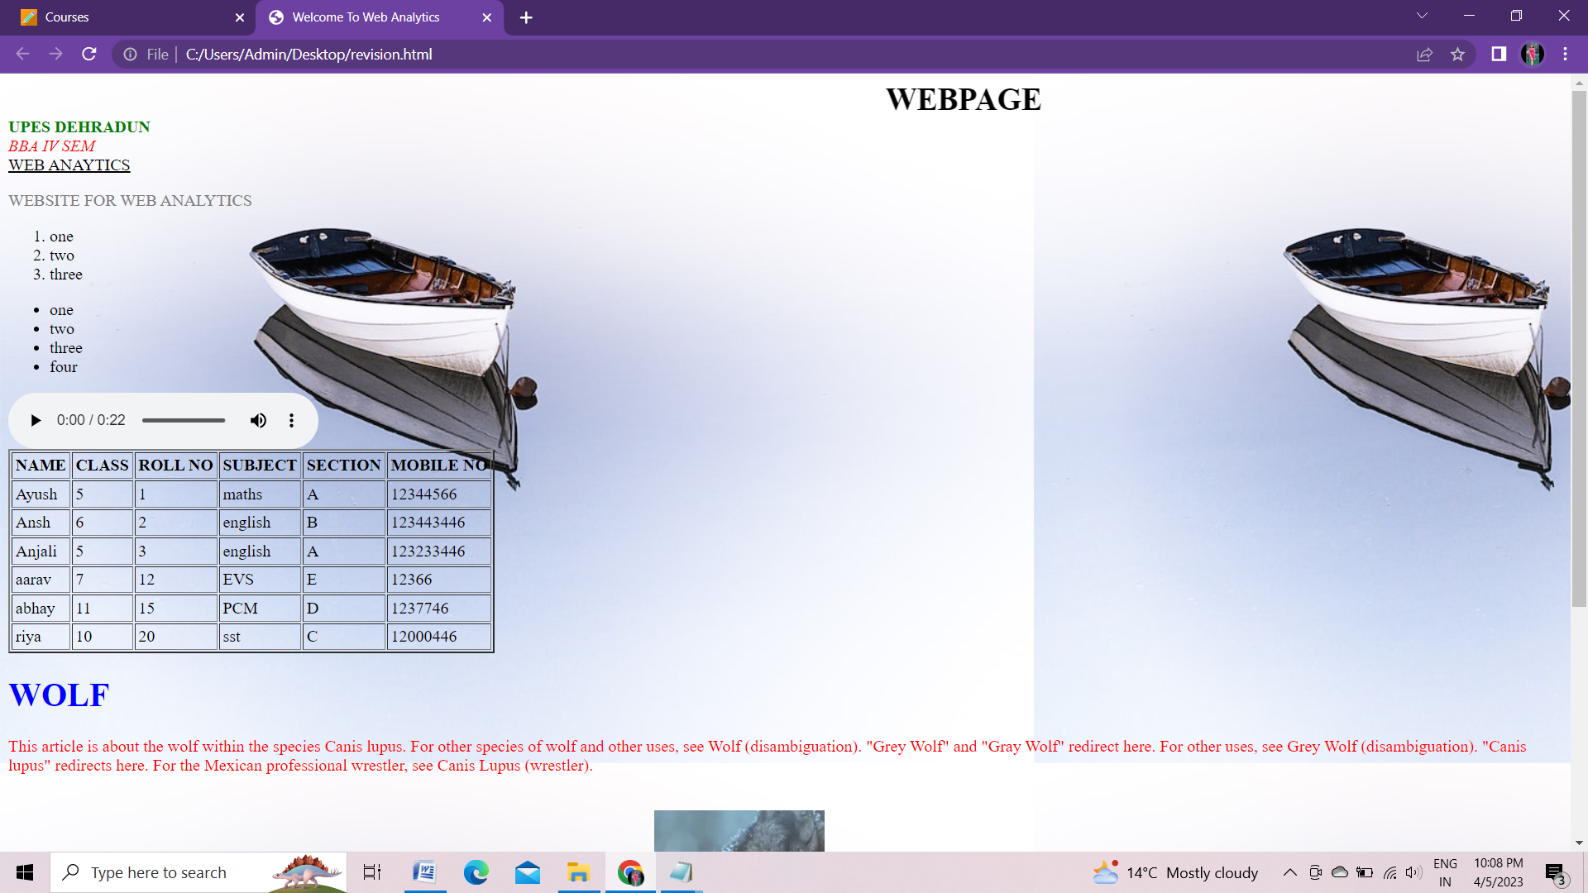

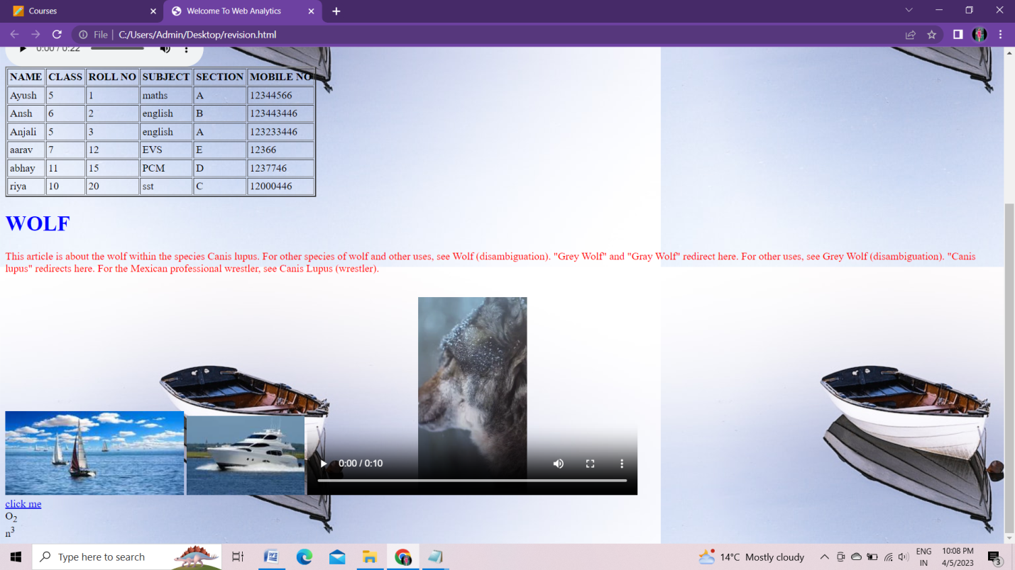

**CSS:**

body{

background-powderblue;

}

b{ color:green}

h1{

color:blue;

}

i{color:red;}

p{

color:grey;

}

marquee{

font-size: 30px;

font-weight: 800;

color: $black

#000;}

font-family: sans-serif;

}